 |  | TERMO DE ACEITE TÉCNICO
Solicitante: VIVO- Projeto Escolas Rurais
NOC/Operador: Rogerio Momi Frias |  |  | Cliente: VIVO
Empresa  EMC Brasil | VSAT-ID  VIVO-PER- |  | Link kbps  256/128 | Plataforma  VSAT
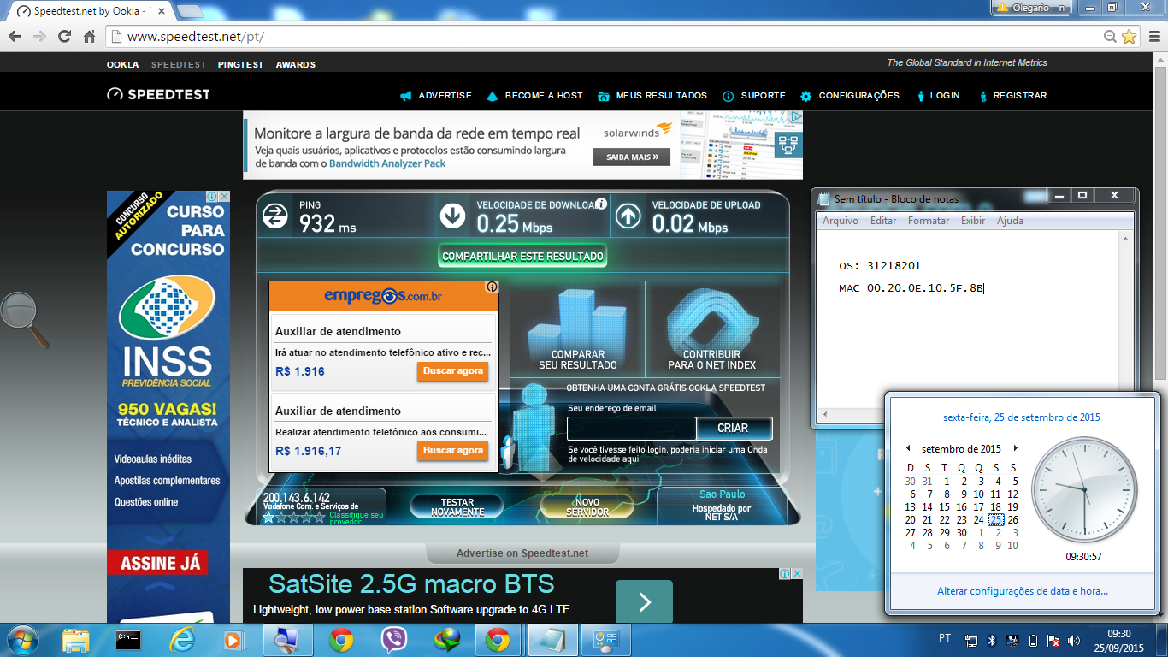

Satellite (DVB) RX Configuration
--------------------------------
Auto start : Enabled
Max MODCOD : 23 16APSK-9/10 (SNR threshold: 23.5 dB)
RX watchdog : 15 minute

Idx Pri SymbRate[Msps] Freq[GHz] Mode PopId Enable
* 0 0 9.320000 12.055825 DVB-S2 4 Yes
1 1 0.000000 0.000000 DVB-S2 2 No

Satellite (DVB) Receiver Status
--------------------------------
Rx State : On
DVB State : Forward link up
Network : 1326, GlobalIP@Telstar-14R
Frequency : 12.055550 GHz
Symbol Rate : 9.320003 Msps
S2 ModCod
- receiving : 16 8PSK-8/9
- current max : 23 16APSK-9/10
Pilot : On
Frame length : Short
DVB S2 Mode : ACM
Roll off : 0.25
SNR : 14.9 dB
Input Power : -27 dBm

Satellite (DVB) TX Configuration
--------------------------------
Auto start : Enabled
IDU Output Power : -30 dBm
IDU Max Output Power: 0.0 dBm
ODU Output Power : 34.7 dBm
EIRP : 48.0 dBW
Default CW Frequency: 14.125500 GHz
ATM mode : VC-Mux
Header Compression : None

Satellite (DVB) Transmitter Status
--------------------------------
State : On (TDMA)
IDU Output Power : -21.4 dBm
ODU Output Power : 33.5 dBm
EIRP : 46.8 dBW
Eb/No : 15.5 dB
Header Compression : Disabled
Timing correction : -46 us (261021 us)
Frequency correction: -340 Hz

Pinging 10.53.0.201 with 32 bytes of data:

Reply from 10.53.0.201: bytes=32 time=2530ms TTL=61
Reply from 10.53.0.201: bytes=32 time=915ms TTL=61
Reply from 10.53.0.201: bytes=32 time=655ms TTL=61
Reply from 10.53.0.201: bytes=32 time=572ms TTL=61

Ping statistics for 10.53.0.201:
Packets: Sent = 4, Received = 4, Lost = 0 (0% loss),
Approximate round trip times in milli-seconds:
Minimum = 572ms, Maximum = 2530ms, Average = 1168ms

C:\Documents and Settings\Administrator.DVB-RCS>ping 10.29.3.233

Pinging 10.29.3.233 with 32 bytes of data:

Reply from 10.29.3.233: bytes=32 time=1644ms TTL=61
Reply from 10.29.3.233: bytes=32 time=737ms TTL=61
Reply from 10.29.3.233: bytes=32 time=727ms TTL=61
Reply from 10.29.3.233: bytes=32 time=763ms TTL=61

Ping statistics for 10.29.3.233:
Packets: Sent = 4, Received = 4, Lost = 0 (0% loss),
Approximate round trip times in milli-seconds:
Minimum = 727ms, Maximum = 1644ms, Average = 967ms

ping 8.8.8.8
64 bytes from 8.8.8.8: time=2030 ms
64 bytes from 8.8.8.8: time=1250 ms
64 bytes from 8.8.8.8: time=940 ms
64 bytes from 8.8.8.8: time=920 ms
64 bytes from 8.8.8.8: time=930 ms

--- 8.8.8.8 ping statistics ---
5 packets transmitted, 5 received, 0.00 percent packet loss
rtt min/avg/max = 920/1210/2030 ms

